

OOP Lab-04 Tasks

Name: Syed Muhammad Raza Ali

Enrolment: 02-134231-028

Course: OOP Lab

Faculty: Miss Hafsa Munawar

Designing and implementing Java programs that deal with:

1. **Static Methods**
2. **Recursion**

Exercises

Exercise 1 *(PatientInfo.java)*

Consider you are a receptionist at hospital and whenever the patient comes you’re to take his following info P_number, P_Name, P_age , P_email, P_contact, P_Complain and P_bill then print the receipt for customer so method responsible for taking customer’s info is called as Take_Patient_data() and method responsible print receipt is called as Print_Receipt()

Hint: Create global variable that is outside of the main method and use them in both methods for taking and printing customer’s details

NOTE: These functions must not be static

Code:

Patient Class:

package com.mycompany.mavenproject2;

import java.util.Scanner;

public class Patient {

String p_name,p_email,p_complain;

int p_number,p_age,p_bill,p_contact;

public void takePatientRecord(){

Scanner p_input = new Scanner(System.in);

System.out.print("Enter your'e Name : ");

p_name = p_input.nextLine();

System.out.print("Enter your'e Email : ");

p_email = p_input.nextLine();

System.out.print("Enter your'e Complain : ");

p_complain = p_input.nextLine();

System.out.print("Enter your'e Patient ID : ");

p_number = p_input.nextInt();

System.out.print("Enter your'e Age : ");

p_age = p_input.nextInt();

System.out.print("Enter your'e Contact no : ");

p_contact = p_input.nextInt();

p_input.nextLine();

System.out.print("Enter your'e Bill : ");

p_bill = p_input.nextInt();

}

public void printReceipt(){

System.out.println("===================== Reciept =====================");

System.out.println("Patient's Name : "+ p_name);

System.out.println("Patient's Email : "+ p_email);

System.out.println("Patient's Complain : "+ p_complain);

System.out.println("Patient's ID : "+ p_number);

System.out.println("Patient's Age : "+ p_age);

System.out.println("Patient's Contact : "+ p_contact);

System.out.println("Patient's Bill : "+ p_bill);

System.out.println("===================================================");

}

}

Application Class:

package com.mycompany.mavenproject2;

import java.util.Scanner;

public class Mavenproject2 {

public static void main(String[] args) {

// Task--01

Patient obj = new Patient();

obj.takePatientRecord();

obj.printReceipt();

}

}

Output:

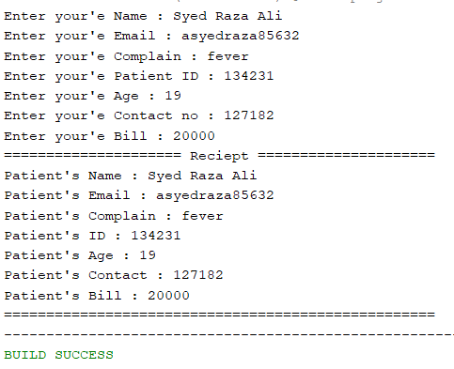

Exercise 2 *(Sum.java)*

Write the following 2 static methods:

**public static int ComputeOddSum(int input)**

**public static int ComputeEvenSum(int input)**

The method **ComputeOddSum** find the sum of all odd numbers less than input (should be recursive function).

The method **ComputeEvenSum** find the sum of all even numbers less than input.

Code:

Task2 Class:

package com.mycompany.mavenproject2;

public class Task2 {

static int i = 0;

static int sum = 0;

//for Odd Numbers

public static int computeOddSum(int number){

if(i<number){

if(i%2 != 0){

sum+=i;

}

i+=1;

computeOddSum(number);

}

i = 0;

return sum;

}

//For Even Numbers

public static int computeEvenSum(int number){

if(i<number){

if(i%2 == 0){

sum+=i;

}

i+=1;

computeEvenSum(number);

}

i = 0;

return sum;

}

}

Application class:

package com.mycompany.mavenproject2;

import java.util.Scanner;

public class Mavenproject2 {

public static void main(String[] args) {

//task---02

Scanner input = new Scanner(System.in);

System.out.println("Enter an integar ");

int number = input.nextInt();

System.out.println("The sum of all Odd numbers = "+Task2.computeOddSum(number));

System.out.println("The sum of all Even numbers = "+Task2.computeEvenSum(number));

}

}

Output:

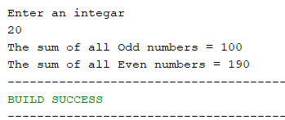

Exercise 3 *(MatrixTest.java)*

Create a Matrix named as Mat_1 of size 3x3 and ask user to insert values take another matrix named as Mat_2 of size 3x3 again and then implement following equations

1. (Mat_1*3)+(Mat_2)*2
2. (Mat_2 -3) *2
3. (Mat_2*5) – (Mat_1-2)

Code:

Task3 Class:

package com.mycompany.mavenproject2;

import java.util.Scanner;

class Task3{

int[][] mat_1 = new int[3][3];

int[][] mat_2 = new int[3][3];

Scanner input = new Scanner(System.in);

//for tasking inputs in arrays

void inputInArrays(){

//For mat_1

System.out.println("Enter the elements of mat_1");

for(int i = 0;i<mat_1.length;i++){

for(int j = 0;j<mat_1.length;j++){

System.out.print("Enter the value of position "+i+""+j+" : ");

mat_1[i][j] = input.nextInt();

}

}

//For mat_2

System.out.println("Enter the elements of mat_2");

for(int i = 0;i<mat_2.length;i++){

for(int j = 0;j<mat_2.length;j++){

System.out.print("Enter the value of position "+i+""+j+" : ");

mat_2[i][j] = input.nextInt();

}

}

//printing arrays

System.out.println("================== Arrays After Taking Input ==================");

System.out.println("mat_1 is given as : ");

for(int i = 0; i<mat_1.length; i++){

for(int j = 0; j<mat_1.length; j++){

System.out.print(mat_1[i][j] + "\t");

}

System.out.print("\n");

}

System.out.println("mat_2 is given as : ");

for(int i = 0; i<mat_2.length; i++){

for(int j = 0; j<mat_2.length; j++){

System.out.print(mat_2[i][j] + "\t");

}

System.out.print("\n");

}

}

//For Equation1

void equation1(){

//mat_1 * 3

for(int i = 0; i<mat_1.length; i++){

for(int j = 0; j<mat_1.length; j++){

mat_1[i][j] = (mat_1[i][j]) * 3;

}

}

//mat_2 * 2

for(int i = 0; i<mat_2.length; i++){

for(int j = 0; j<mat_2.length; j++){

mat_2[i][j] = (mat_2[i][j]) * 2;

}

}

//adding both arrys

int[][] mat_ans = new int[3][3];

for(int i = 0; i<mat_ans.length; i++){

for(int j = 0; j<mat_ans.length; j++){

mat_ans[i][j] = mat_1[i][j] + mat_ans[i][j];

}

}

//printing result

System.out.println("================== Arrays After Performing Eq1 ==================");

System.out.println("(Mat_1*3) + (Mat_2*2)");

for(int i = 0; i<mat_ans.length; i++){

for(int j = 0; j<mat_ans.length; j++){

System.out.print(mat_ans[i][j] +"\t");

}

System.out.print("\n");

}

}

//for equation 2

void equation2(){

//mat_2 - 3

for(int i = 0; i<mat_2.length; i++){

for(int j = 0; j<mat_2.length; j++){

mat_2[i][j] = (mat_2[i][j]) - 3;

}

}

//mat_2-3 *2

int[][] mat_ans = new int[3][3];

for(int i = 0; i<mat_ans.length; i++){

for(int j = 0; j<mat_ans.length; j++){

mat_ans[i][j] = mat_2[i][j] * 2;

}

}

//printing final array

System.out.println("================== Arrays After Performing Eq2 ==================");

System.out.println("(Mat_2-3)*2");

for(int i = 0; i<mat_ans.length; i++){

for(int j = 0; j<mat_ans.length; j++){

System.out.print(mat_ans[i][j] +"\t");

}

System.out.print("\n");

}

}

//for equation3

void equation3(){

//mat_2*5

for(int i = 0; i<mat_2.length; i++){

for(int j = 0; j<mat_2.length; j++){

mat_2[i][j] = (mat_2[i][j]) * 5;

}

}

//mat_1-2

for(int i = 0; i<mat_1.length; i++){

for(int j = 0; j<mat_1.length; j++){

mat_1[i][j] = (mat_1[i][j]) - 2;

}

}

//for final array

int[][] mat_ans = new int[3][3];

for(int i = 0; i<mat_ans.length; i++){

for(int j = 0; j<mat_ans.length; j++){

mat_ans[i][j] = mat_2[i][j] - mat_1[i][j];

}

}

//printing final array

System.out.println("================== Arrays After Performing Eq3 ==================");

System.out.println("(Mat_2*5)-(Mat_1*2)");

for(int i = 0; i<mat_ans.length; i++){

for(int j = 0; j<mat_ans.length; j++){

System.out.print(mat_ans[i][j] +"\t");

}

System.out.print("\n");

}

}

}

Application class:

package com.mycompany.mavenproject2;

import java.util.Scanner;

public class Mavenproject2 {

public static void main(String[] args) {

//task---03

Task3 obj = new Task3();

obj.inputInArrays();

obj.equation1();

obj.equation2();

obj.equation3();

}

}

Output (For eq1):

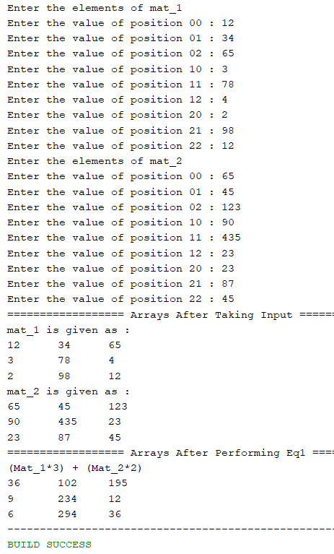

Output (For eq2):

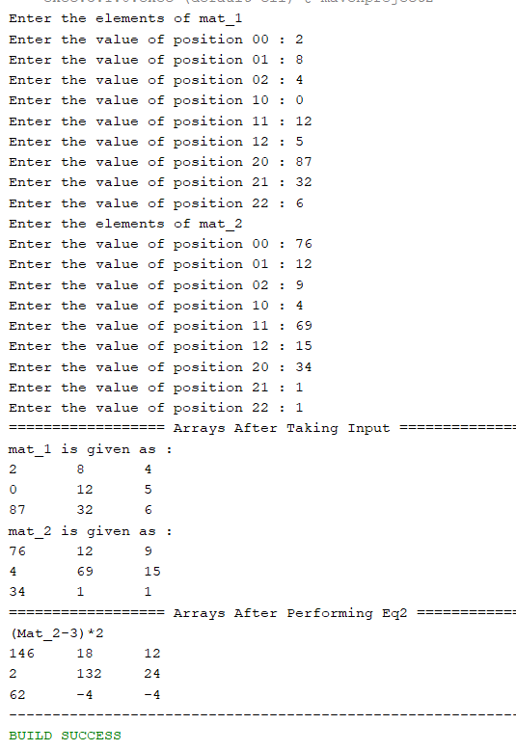

Output (For eq3):

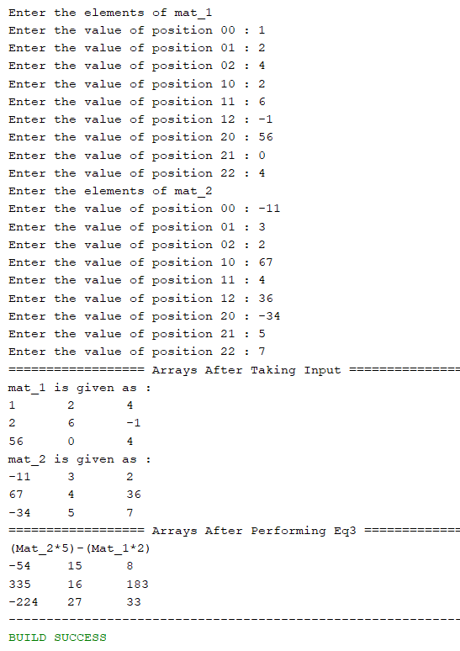

Exercise 4 (Recursion) *(prodcut.java)*

Write a recursive method to get multiply of all number from 1 up to given number. E.g. Number = 5 Result must be sum (1*2*3*4*5)

Code:

Task4 Class:

package com.mycompany.mavenproject2;

import java.util.Scanner;

class Task4 {

int i = 1;

int product = 1;

int number = 0;

public void input(){

System.out.print("Enter an integar : ");

Scanner input = new Scanner(System.in);

number = input.nextInt();

}

public int computeProduct() {

if (number != 0) {

if (i <= number) {

product = product * i;

i = i + 1;

computeProduct();

}

}

return product;

}

}

Application class:

package com.mycompany.mavenproject2;

import java.util.Scanner;

public class Mavenproject2 {

public static void main(String[] args) {

Task4 obj = new Task4();

obj.input();

System.out.println("The Final product is : "+obj.computeProduct());

}

}

Output:

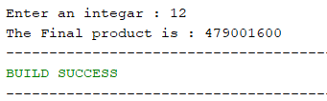

Exercise 5 (Recursion) *(NumberSum.java)*

Write a recursive function that takes two int as arguments and compute the sum of all number between provided two positive integers for example

If 1 and 20 are passed to the function answer should be 210.

Code:

Task5 Class:

package com.mycompany.mavenproject2;

import java.util.Scanner;

class Task5{

int a,b;

int i = 0,sum = 0;

void input(){

Scanner input = new Scanner(System.in);

System.out.print("Enter a positive integar : ");

a = input.nextInt();

System.out.print("Enter another positive integar : ");

b = input.nextInt();

}

int computeSum(){

if(a>=0 && b>=0 && a<=b){

if(i<=b){

sum+=a;

a+=1;

computeSum();

}

}

return sum;

}

}

Application class:

package com.mycompany.mavenproject2;

import java.util.Scanner;

public class Mavenproject2 {

public static void main(String[] args) {

Task5 obj = new Task5();

obj.input();

System.out.print("The sum of all positive numbers between "+obj.a+" and "+obj.b+" is : "+obj.computeSum());

}

}

Output:

